Template for abstracts for the NCK days 2017
M.J. Baptist¹, A.V. de Groot ¹ & M.C. van Oeveren²
¹ Wageningen University & Research, martin.baptist@wur.nl, alma.degroot@wur.nl
² Deltares, Claire.vanOeveren@deltares.nl

Description of the template
Please use the given heading style for the title (Times New Roman 12 pt, bold, small caps, centered). Author names, affiliation, and e-mail are written in Times New Roman 10 pt, centered. The abstract itself is written in English. Use 11 pt Times New Roman, justified and make your headings bold. You may use your own headings, for example: introduction, methods, results, discussion, references, acknowledgements. It is highly recommended to illustrate your work with a nice figure. The figure caption is written in Times New Roman 10 pt, italics. The total length of the abstract (including figures, references, etc.) should not exceed 1 A4!

Abstracts should be submitted electronically (as *.docx) by e-mail to: nck2017@wur.nl. Deadline for the submission of abstracts is Wednesday 1 February 2017.

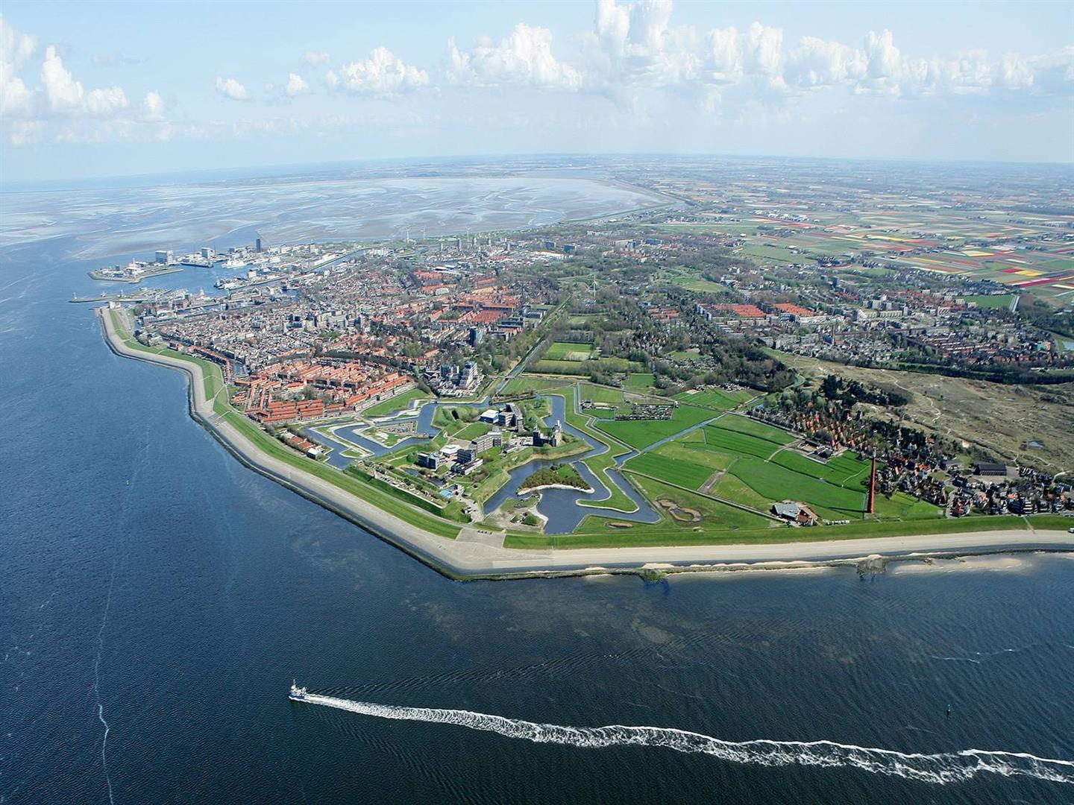
Bird’s-eye view of the location of the NCK days 2017. Den Helder is surrounded by the sea in three directions: Wadden Sea with Balgzand tidal flats in the background, Marsdiep tidal inlet to the left, North Sea in front.

