Template for abstracts for the NCK Days 2018
G. Ologist^{1,2}*, I.M.A. Beach^{1,2}, C. Shelf³
¹ Affiliation 1 (Title only), ² Affiliation 2 (Title only), …
* g.ologist@affiliation1.somehting

Description of research
This is where the description of your research starts. The abstract will be in English. Please use 11pt Times New Roman, justified and make your headings bold. It is highly recommended to illustrate your work with a nice figure, such as the one given below. The length of the abstract (including figure) should not exceed 1 A4.

Abstracts should be submitted electronically (as *.doc) by email to: sytze.vanheteren@tno.nl.
Deadline for the submission of abstracts is February 7, 2018.

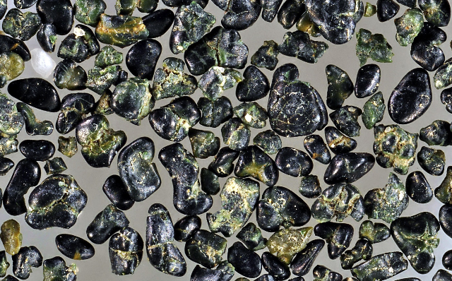

Figure 1 Glauconite sand from Paleogene shallow-marine sediment underneath the Zeeland coastal zone (photo: P.C. van der Klugt).

