Template for abstracts for the NCK days 2016
D.S. van Maren^{1,2}*, A.J.F. van der Spek^{1,2}, J. Vroom¹
¹ Deltares, Bas.vanMaren@deltares.nl, Ad.vanderSpek@deltares.nl, Julia.Vroom@deltares.nl
² Delft University of Technology

Description of research
This is where the description of your research starts. The abstract will be in English. Please use 11pt Times New Roman, justified and make your headings bold. It is highly recommended to illustrate your work with a nice figure, such as the one given below. The total length of the abstract (including figures, references, etc.) should not exceed 1 A4.

Abstracts should be submitted electronically (as *.doc or *.pdf) by email to: ml-nck-list@deltares.nl.
Deadline for the submission of abstracts is 5 February 2016.

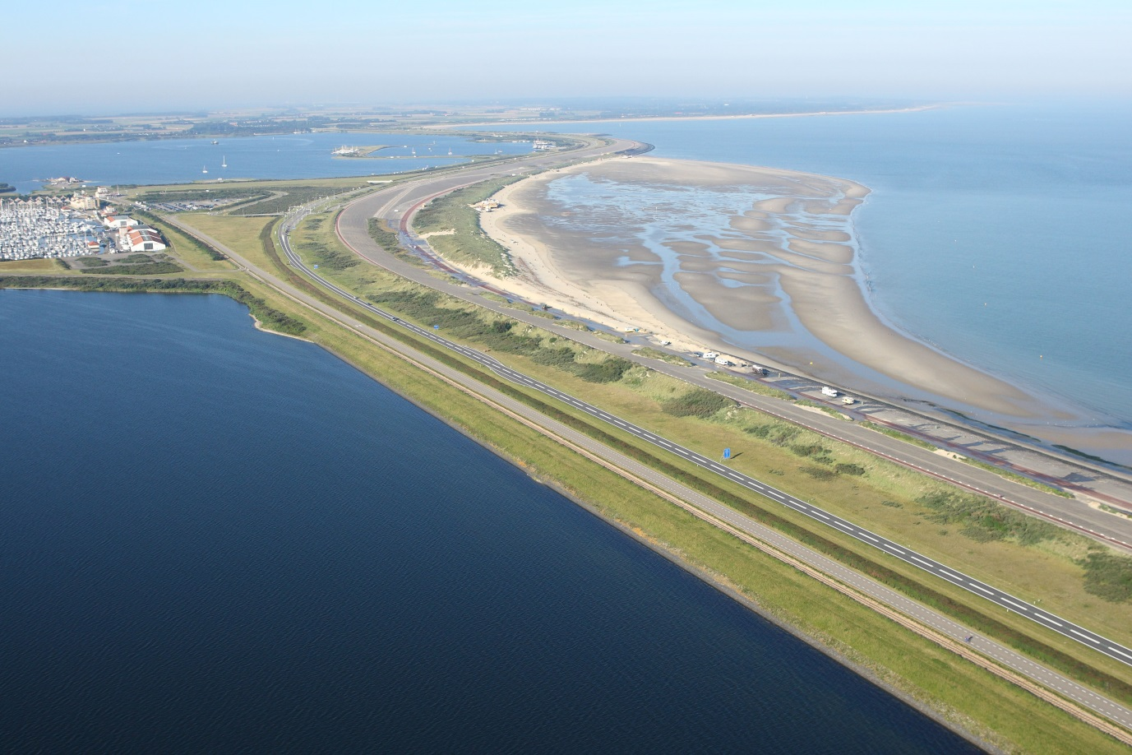
Figure 1 Bird’s-eye view of the location of the NCK-days 2016 looking in Southern direction. Source: beeldbank.rws.nl.

