TITLE; NO BLANK LINE BETWEEN THE TITLE AND THE PAPER TOP MARGIN CAPITAL LETTERS; PAGE-CENTERED; MAX. 2 LINES/70 TOTAL CHARACTERS

Forename Surname, Your Institute, name@domain.com
Forename Surname, Your Institute, name@domain.com

TOPIC
Please indicate the topic of your abstract: Processes (Hydrodynamics; Morphodynamics), Environment (Sandy coasts and shorelines; Coral, gravel and rocky coasts and shorelines; Vegetated coasts and shorelines; Ports, waterways and ships), Numerics (Numerical methods, Boundary conditions, Coupling to other models). One or more topics can be chosen.

PREPARATION AND SUBMITTAL
The Book of Abstracts, which will be given to participants at registration, will be reproduced directly from your manuscript. Abstracts must be produced to fit A4 paper. The text, together with tables, equations and illustrations, must fill no more than one page, in 1-column layout (as in this accompanying example).

SUBHEADING
Authors are required to supply abstracts as PDF format files. Submissions can be received via XBeachXConference@deltares.nl.

SUBHEADING
The official language of the conference: English. Paper Format: A4 portrait. Margins and fonts: as indicated in this format. Main text justified. Spacing: single. Font: for the title: size 12 Microsoft Sans Serif, capital letters, bold; for the names of the authors: size 9 Microsoft Sans Serif, regular; for the text: size 9 Microsoft Sans Serif, regular. Page numbering: no page numbers. Title: leave no blank line between the title and the paper top margin; the title must be in capital letters, page-centered; maximum of two (2) lines and/or 70 total characters for the title. Name(s) of authors(s): leave 1 blank line after the title;. The name of the presented author should be underlined. Main text: one page only, including figures and tables; paragraphs separated by one line. Footnotes: do not use footnotes. Figures and tables: include the figures and tables precisely in the place you want them.

SUBHEADING
Mathematics: equations should be typed into the body of the text, or incorporated as an equation editor or graphic object; equations should be numbered. Bibliographic references: in the text, indicate the last name of the author followed by the year of publication in brackets; if there are several references of the same author in the same year, use a suffix a, b, .. after the year; make a list of references at the end of the text sorted by alphabetic order of the last name of the first author, followed by the names of the co-authors (if any), editor, place and year of publication (or complete reference of the journal where the article or paper was published). File format for submission: use PDF format; identify the files as “LastnameFirstname.pdf”, where the name is the presenting author; e.g. RoelvinkDano.pdf. If you have any queries on the preparation of your abstract, please contact XBeachXConference@deltares.nl

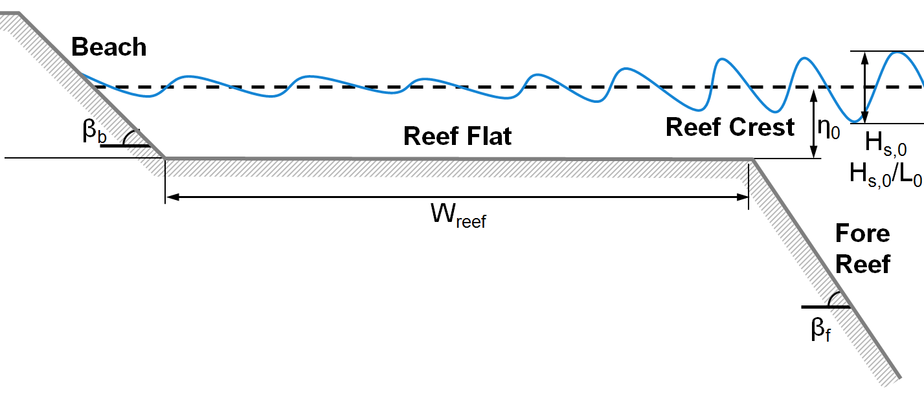

Figure 1 –Schematization of an XBeach simulation

ATTENTION
Please note that this example of the one-page abstract is a style sheet, which makes the work much easier. Please do not try to include more text than the space provided by this instruction.

REFERENCES
Surname no initials please (year of publication in brackets 2007):
Author, co-author (2006): Title, Coastal Engineering, ELSEVIER, vol. 10, pp. 32-39.

