Template for abstracts for the NCK days 2019
M. van der Vegt¹*, L.B. Brakenhoff¹, J. Vroom²
¹ Utrecht University, m.vandervegt@uu.nl, l.b.brakenhoff@uu.nl
² Deltares, Julia.Vroom@deltares.nl

Introduction
The abstract will be in English. Please use 11pt Times New Roman, justified and make your headings bold. It is highly recommended to illustrate your work with a nice figure, such as the one given below. The total length of the abstract (including figures, references, etc.) should not exceed 1 A4.

Methods
Abstracts should be submitted electronically (as *.doc or *.docx) by email to: nckdays2019@uu.nl.
Deadline for the submission of abstracts is 1 February 2019!

Results
The NCK days 2019 will take place on 21 and 22 March 2019, in the Zuiderzeemuseum, Enkhuizen (Figure 1).
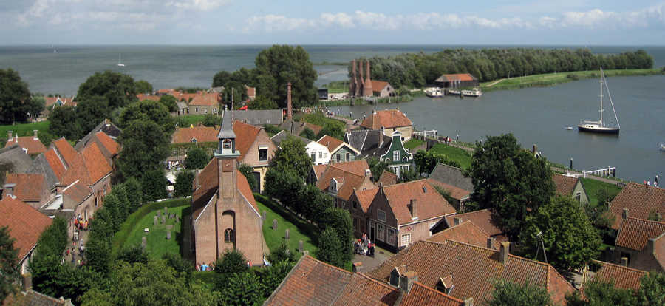
Figure 1 Bird’s-eye view of the location of the NCK-days 2019. Source: zuiderzeemuseum.nl.

