Template for abstracts for the NCK days 2020
T. Gerkema¹*, T.J. Bouma¹, J. Vroom²
¹ NIOZ, Theo.gerkema@nioz.nl, tjeerd.bouma@nioz.nl
² Deltares, Julia.Vroom@deltares.nl

Introduction
The abstract will be in English. Please use 11pt Times New Roman, justified and make your headings bold. It is highly recommended to illustrate your work with a nice figure, such as the one given below. The figure should not be cropped in Word. If cropping is needed, use an image editor. Insert you figure with “Wrap text > Square” and not “In line with text”. This is important, as the Book of Abstract will be converted to HTML pages and published at the NCK website. The total length of the abstract (including figures, references, etc.) should not exceed 1 A4.

Methods
Abstracts should be submitted electronically (as *.doc or *.docx) by email to: nckdays2020@nioz.nl.
Deadline for the submission of abstracts is 31 January 2020!

Results
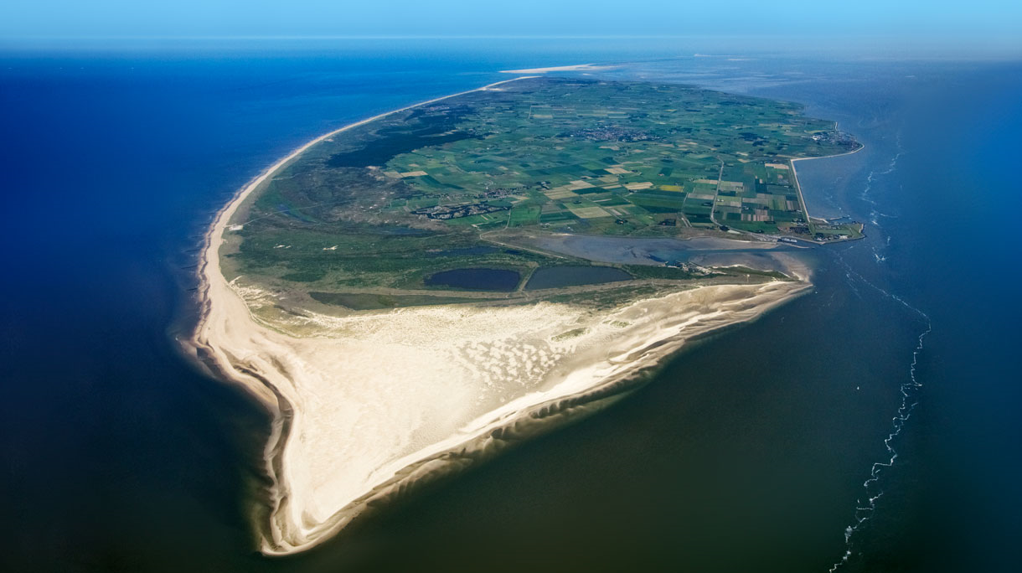
The NCK days 2020 will take place on 18 to 20 March 2020 at NIOZ Texel (Figure 1).
Figure 1 Bird’s-eye view of the island of Texel as seen from the south. Source: Getty images.

