Template and instruction for abstracts for the NCK days 2021
T. Gerkema¹*, J. Vroom²
¹ NIOZ, theo.gerkema@nioz.nl
² Deltares, julia.vroom@deltares.nl

Introduction
The abstract has to be in English. Use font Times New Roman: 12pt for the title, and 11pt for the rest (incl for affiliation, caption and references), and justified. Make the title bold and centered (normal case, not in capitals). State the names and affiliations in the format indicated above, adding an asterisk to the person who presents. Use boldface for titles of sections. It is recommended to illustrate your work with one nice figure. The figure should not be cropped in Word. If cropping is needed, use an image editor. Insert your figure with “Wrap text > Square” and not “In line with text”. This is important, as the Book of Abstract will be converted to HTML pages and published at the NCK website. Do not embed the caption in the Figure but put it is as a line in the text, in italics. The total length of the abstract (including figures, references, etc.) should not exceed 1 A4.

Methods
Abstracts should be submitted electronically as *.docx (not pdf!) by email to: nckdays2021@nioz.nl.
Deadline for the submission of abstracts is Sunday 21 February (NB: there will be no extension!)

Results
The NCK days will take place online on 25 and 26 March 2021. There will be no posters, only short pre-recorded presentations, each followed by a live discussion, but the number of slots is limited to 60, so it may not be possible to accept all abstracts for a presentation. However, they will be included in the (online) Book of Abstracts.

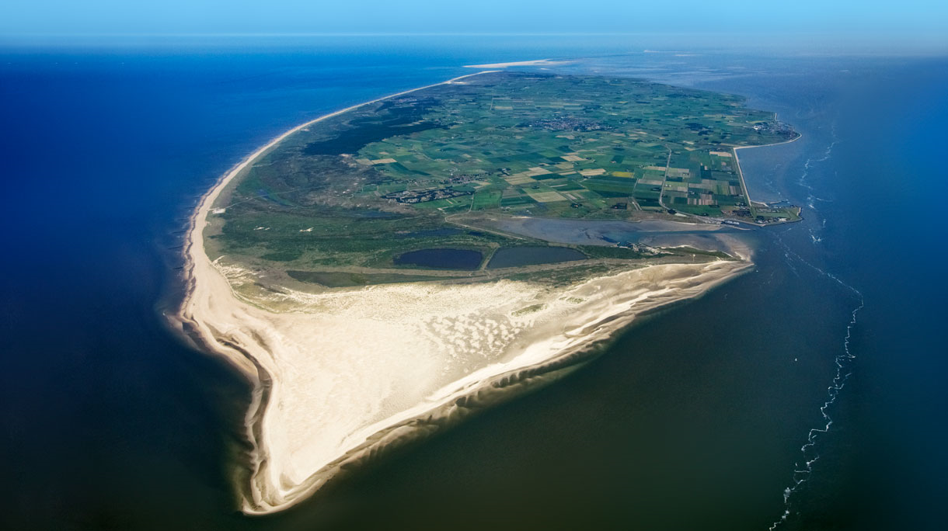
Figure: Bird’s-eye view of the island of Texel as seen from the south. Source: Getty images.

