Template and instruction for abstracts for the NCK days 2022
J.J. van der Werf^{1,2}*, J. Vroom²
¹ University of Twente; ² Deltares
*corresponding author: j.j.vanderwerf@utwente.nl

Introduction
The abstract has to be in English. Please use font Times New Roman: 12pt for the title, and 11pt for everything else (including for affiliation, caption and references). Use justified text and use bold face for headings. The title should be bold and centred (normal case, not in capitals). State author names and affiliations in the format indicated above, adding an asterisk to the person who presents.
It is recommended to illustrate your work with one nice figure. The figure should not be cropped in Word. If cropping is needed, use an image editor. Insert your figure with “Wrap text > Square” and not “In line with text”. This is important, as the Book of Abstract will be converted to HTML pages for publication on the NCK website. Do not embed the caption in the figure but put it is as a line in the text, in italics.
References (e.g. Hirabayashi et al., 2013) can be added in this abstract. The total length of the abstract (including figure, references, etc.) should not exceed 1 A4. Please do not change margins and font size.

Methods
Abstracts should be submitted electronically as *.docx and *.pdf via this website. You will receive a confirmation email once the abstract is submitted. Should you not receive this email, please contact us (nckdays2022-et@utwente.nl) so we can check to make sure your submission went through correctly.

Results
The NCK days will take place on 16 - 18 March 2022 at the University of Twente. There will be posters and oral presentations. All accepted abstracts will be included in the online Book of Abstracts.

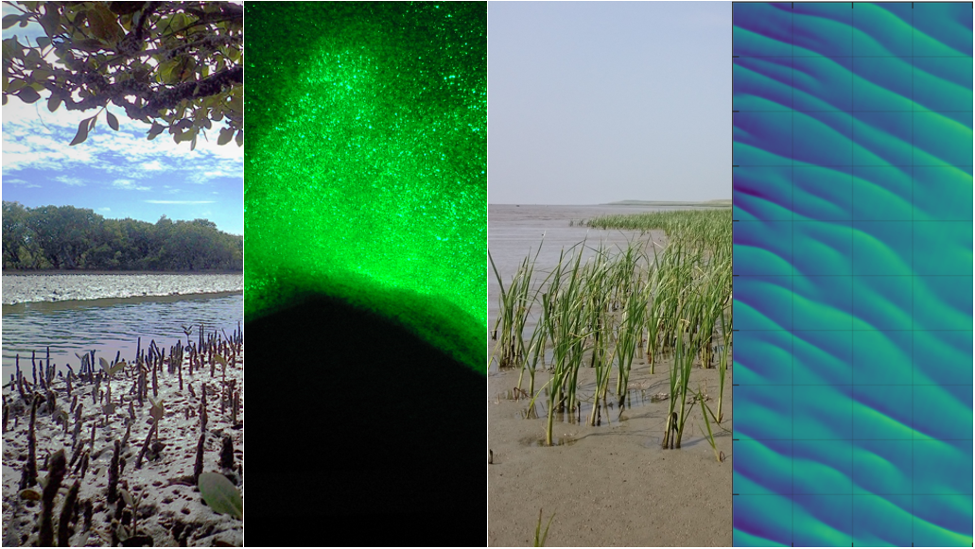
Figure 1: Research fields in marine and coastal systems at the UT (image courtesy: Erik Horstman; Jebbe van der Werf; Pim Willemsen; Johan Damveld).

References
Hirabayashi, Y., Mahendran, R., Koirala, S., Konoshima, L., Yamazaki, D., Watanabe, S., Kim, H. & Kanae, S. (2013). Global flood risk under climate change. Nature climate change, 3(9), 816-821. https://doi.org/10.1038/nclimate1911

