Template and instruction for abstracts for the NCK days 2023
M. Ferguson^{1,2}*, A. Sandoval²
¹ Institute of Higher Education; ² Cuban Institute of Technology
*corresponding author: M.Ferguson@IoHE.nl

Introduction
The abstract has to be in English. Please use font Times New Roman: 12pt for the title, and 11pt for everything else (including for affiliation, caption and references). Use justified text and use bold face for headings. The title should be bold and centred (normal case, not in capitals). State author names and affiliations in the format indicated above, adding an asterisk to the person who presents.
It is recommended to illustrate your work with one nice figure. The figure should not be cropped in Word. If cropping is needed, use an image editor. Insert your figure with “Wrap text > Square” and not “In line with text”. This is important, as the Book of Abstract will be converted to HTML pages for publication on the NCK website. Do not embed the caption in the figure but put it is as a line in the text, in italics.
References (e.g. Hirabayashi et al., 2013) can be added in this abstract. The total length of the abstract (including figure, references, etc.) should not exceed 1 A4. Please do not change margins and font size.

Methods
Abstracts should be submitted electronically as *.docx and *.pdf via the registration website (follow this link, the registration website will be open mid January 2023). You will receive a confirmation email once the abstract is submitted.

Results
The NCK days will take place on 29 - 31 of March 2023 nearby Delft University of Technology. There will be posters and oral presentations. All accepted abstracts will be included in the online Book of Abstracts.

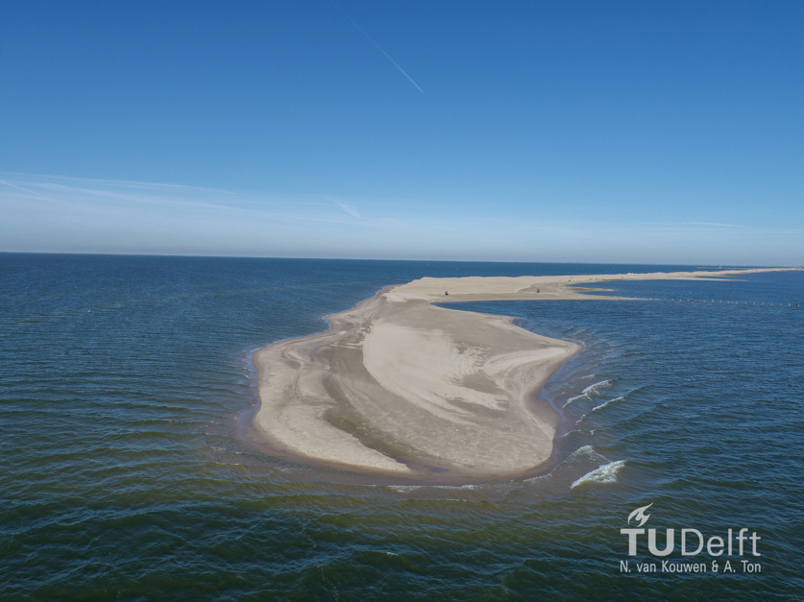

Figure 1: Morphodynamics in the Markerwadden (image courtesy: N. van Kouwen and A. Ton).

References
Hirabayashi, Y., Mahendran, R., Koirala, S., Konoshima, L., Yamazaki, D., Watanabe, S., Kim, H. & Kanae, S. (2013). Global flood risk under climate change. Nature climate change, 3(9), 816-821. https://doi.org/10.1038/nclimate1911

